ANTI - BULLYING POLICY
NEWBURY SCHOOL

Contents
- Policy Statement + Purpose
- Responsibilities
- Newbury Community
- Definition of bullying
- Forms and types of bullying
- Bullying outside of school
- Signs and Symptoms of bullying
- Prevention
- Reporting
- Bullying Cycle – How we manage bullying incidents
- Supporting the student being bullied
- Supporting the student who is bullying
- Restorative Practice
- Useful Links

Policy Statement + Purpose
Newbury Independent School endeavours to consistently maintain a safe and supportive environment in which our students feel comfortable and protected. At Newbury School we promote a zero – tolerance approach towards bullying behaviours. We recognise that all forms of bullying, especially if left unaddressed, can have a devastating effect on individuals; it can create a barrier to learning and have serious consequences for mental wellbeing. By effectively preventing and tackling bullying our school can help to create a safe and disciplined environment, where pupils are able to learn and fulfil their potential.

The purpose of this policy statement is:
• To prevent bullying from happening between children and young people who are a part of our school provision.
• To make sure bullying is stopped as soon as possible if it does happen and that those involved receive the support they need
• To provide information to all staff, volunteers, children and their families about what we should all do to prevent and deal with bullying

This policy has been informed by the following guidelines:

- Preventing and Tackling Bullying (DFE, July. 2017)
- Cyber-bullying: Advice for Head Teachers and School Staff, 2014
- Cyber-bullying: Safe to learn: Embedding Anti-Bullying Work in Schools (DCSF 2007)
- Cyber-bullying: A Whole School Community Issue (DCSF 2007)
- Independent School Standard Regulations 2019
- The Equality Act 2010

Responsibilities:

It is the responsibility of:
- The Behaviour Lead and Head teacher to communicate this policy to the school community, to ensure that disciplinary measures are applied fairly, consistently and reasonably
- All staff, including: governors, senior leadership, teaching and non-teaching staff, to support, uphold and implement this policy accordingly.
- Parents/carers to support their children and work in partnership with the school.
- Pupils to abide by the policy.
- Everyone has a role to play in preventing all forms of bullying (including online) and putting a stop to bullying.
Newbury Community:
- We monitor and review our anti-bullying policy and practice on a regular basis.
- We support staff to promote positive relationships to help prevent bullying.
- We recognise that some members of our community may be more vulnerable to bullying and its impact than others; this may include children with SEND. Being aware of this will help us to develop effective strategies to prevent bullying from happening and provide appropriate support, if required. We will intervene by identifying and tackling bullying behaviour appropriately and promptly.
- We ensure that our pupils are aware that bullying concerns will be dealt with sensitively and effectively; that everyone should feel safe to learn and abide by the anti-bullying policy.
- We require all members of the community to work with the school to uphold the anti-bullying policy.
- We recognise the potential impact of bullying on the wider family of those affected, therefore we will work in partnership with parents/carers regarding all reported bullying concerns and will seek to keep them informed at all stages.
- We will deal promptly with grievances regarding the school response to bullying in line with our complaints policy.
- We will seek to learn from good anti-bullying practice elsewhere.
- We will utilise support from the Local Authority and other relevant organisations when appropriate.

Definition of Bullying:
Bullying includes a range of abusive behaviour that is
- Repeated
- Intended to hurt someone either physically or emotionally
- Presents an imbalance of power
Bullying can often be motivated by prejudice against any of the nine protected characteristics specified under the Equality Act 2010. These are age, disability, gender reassignment, marriage or civil partnership, pregnancy & maternity, race, or religion & belief, sex and sexual orientation. A child can also be bullied because of their appearance & personal possessions, interests, academic abilities, their level of popularity and social skills. In addition, bullying can occur as a result of a child's living situation such as location, being adopted or having caring responsibilities. Bullying is recognised by the school as being a form of peer on peer abuse. It can be emotionally abusive and can cause severe and adverse effects on children’s emotional development.

Forms and types of bullying:
- Bullying can happen to anyone. This policy covers all types and forms of bullying including:
- Bullying related to physical appearance
- Bullying of young carers, children in care or otherwise related to home circumstances
- Bullying related to physical/mental health conditions
- Physical bullying (Violence, pushing, kicking, hitting, punching, throwing objects with the intent to harm another, producing offensive graffiti, taking belongings)
- Emotional bullying (Manipulating, controlling, targeting another person’s feelings, mocking, teasing, threatening, belittling, marginalising, tormenting, name calling, gossiping and humiliating)
- Verbal bullying (using language in a derogatory or offensive manner, such as swearing, racist or homophobic comments)
- Sexual bullying (degrading, objectifying, sexual language, sexual violence, victimising, sexual gestures, sexual harassment)
- Bullying via technology, known as online or cyber bullying (trolling, sharing personal or private information about another, embarrassing and humiliating another, death threats, sending offensive, upsetting and inappropriate messages by phone, text, instant messenger, through gaming, websites, social media sites and apps, and sending offensive or degrading photos or videos.)
- Prejudicial bullying (against people/pupils with protected characteristics)
- Bullying related to race, religion, faith and belief and for those without faith
- Bullying related to ethnicity, nationality or culture
- Bullying related to Special Educational Needs or Disability (SEND)
- Bullying related to sexual orientation (homophobic/biphobic bullying)
- Gender based bullying, including transphobic bullying
- Bullying against teenage parents (pregnancy & maternity under the Equality Act)

Bullying outside of school:

Newbury School is aware of the statutory responsibility to discipline students for poor behaviour outside the school premises. Section 89(5) of the Education and Inspections Act 2006 gives Head teachers the power to discipline students for poor behaviour when they are not on school premises. This can relate to bullying incidents occurring anywhere on or off the school premises. This policy should be used alongside the school’s Safeguarding Children Policy as peer-on-peer abuse must be considered as a potential source of significant harm. Where bullying outside school is reported to school staff, it should be investigated and acted on. The head teacher should also consider whether it is appropriate to notify the police or anti-social behaviour coordinator in their local authority of the actions taken against a pupil. If the misbehaviour could be criminal or poses a serious threat to a member of the public, the police should always be informed.

Signs + Symptoms of bullying:

A student may demonstrate any of the following signs of bullying.
All school staff and parents/carers should be vigilant when observing behaviour to ensure appropriate investigations can take place. The following will equip you with the skills to spot different signs of bullying and some of the symptoms that could come from this.

Emotional and Behavioural signs of bullying | Physical signs of bullying | School signs of bullying
Changes in sleep patterns | Unexplained cuts, bruises or scratches | Calls in sick before school
Changes in eating patterns | Returns home with missing or damaged belongings | Does not want to go to school
Frequent tears or anger | Change of usual clothing/shoes | Changes their route to school
Mood Swings | Returns home hungry | Decline in grades/ results
Nausea | Self – Harming | Decline in classroom engagement
Refuses to communicate | Unusual demands of money or purchases (to bribe the bully) | Insecure/ scared in class
Begins to target younger students/ siblings | Afraid to use their phone or social media | Refuses to be in the same class as others
Continuously ‘looses’ money or starts stealing | Feels sick in the morning | Refuses to go to school trips
Heightened anxiety  And feelings of stress | Nightmares before bed | Isolates themselves before break and lunch
Attempts or threatens suicide or runs away | Nervous or jumpy when phone rings or a cyber-message is received | Starts to abscond
Becomes withdrawn or starts stammering | Bowel incontinence | Begs to be driven to school/ picked up from school
Becomes aggressive or unreasonable | Hair/weight loss (Physical manifestation of stress and anxiety | Hangs around staff members/ safe spaces

Prevention:

At Newbury School we will use various methods for helping children to prevent bullying. This will include:

- Promoting equality and inclusivity throughout all school activities
- Modelling and fostering good relationships by teaching respect and responsibility for self and others
- Adopting zero tolerance for discrimination, harassment and victimisation
- Providing information and guidance at induction to ensure that learners are aware of how to proceed if they or someone else experiences bullying
- Encourage students to be assertive in an appropriate manner
- Channelling aggression through appropriate measures and early intervention
- Providing robust supervision of pupils throughout school activities
- Avoiding exposure to violence, unless pertinent to lesson content and/or discussions around bullying behaviours
- Provide appropriate training for all members of staff to ensure they are aware of how to recognise and prevent bullying in any form
- Provide supportive information through notice boards, posters and child line
- Provide support through key workers and pastoral care
- Have a listening and caring ethos
- Encourage communication and discussion
- Adopt a problem – solving approach and promote restorative practice
- Explore issues through PSHE, Tutorials, Assemblies and Anti – Bullying Week

Reporting:

At Newbury School students can report bullying by:

- Speaking to their allocated key worker/ trusted adult
- Speak to our Pastoral + Behaviour Lead through a Drop in Session
- Use our Pastoral Post Box to report a bullying incident – this can also be done anonymously.
- Call the school to speak with a member of staff

Parents/ Carers can report bullying by:

- Calling the school to speak with our Head Teacher
- Calling the school to speak with our Behaviour and Pastoral Lead
- Emailing the school
- Coming into the school for a meeting with our Head Teacher and/or Head Teacher
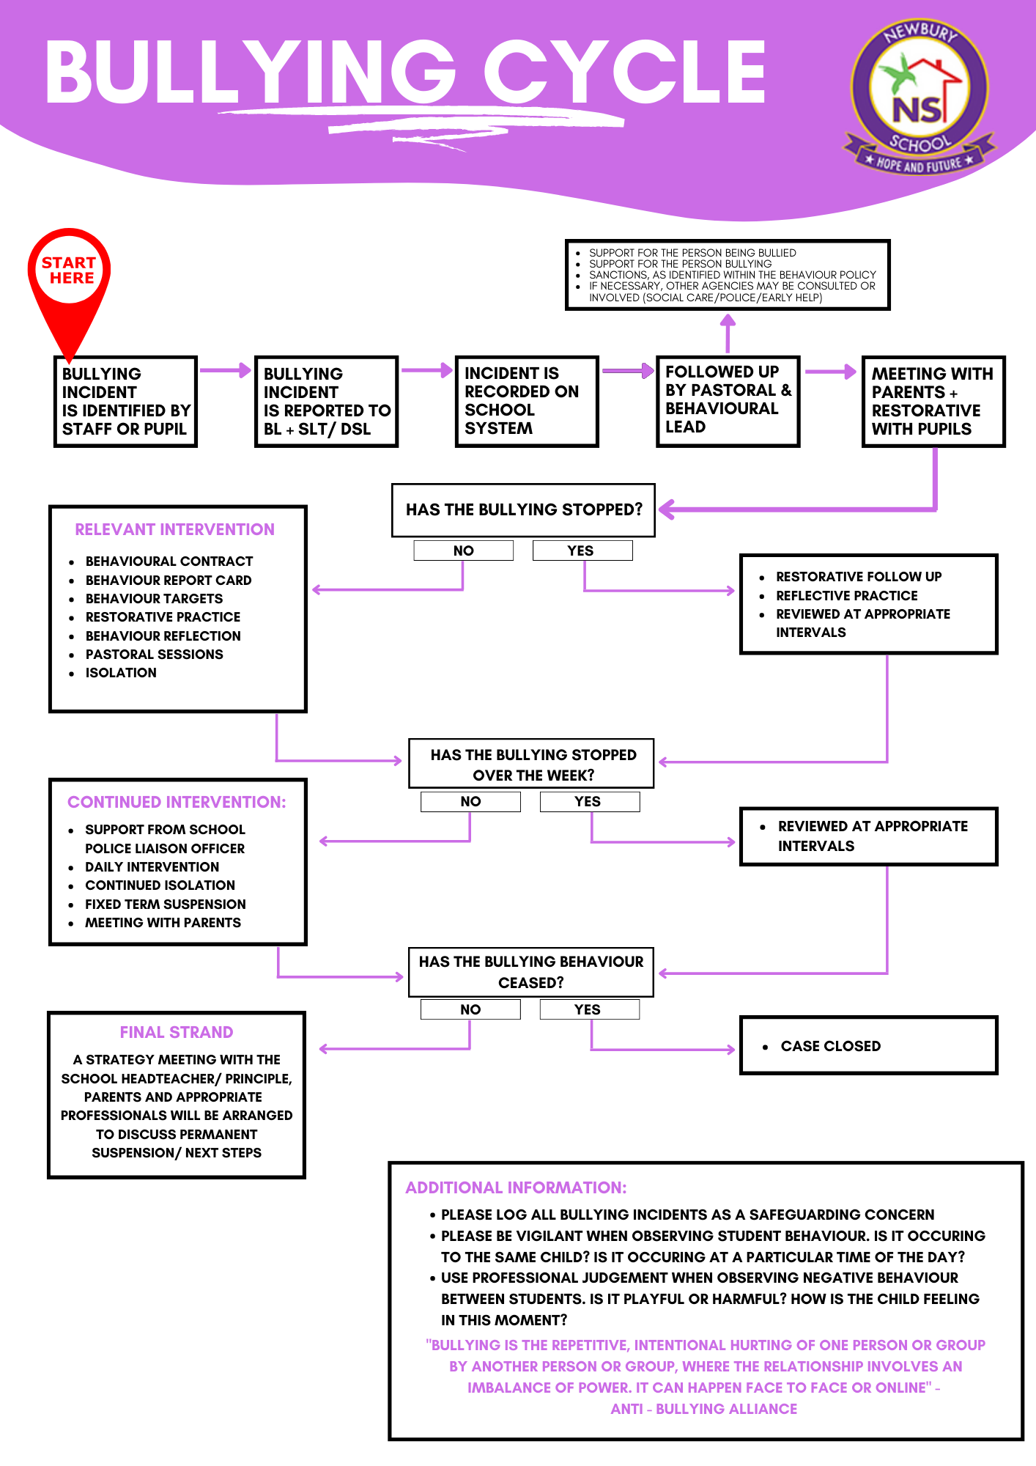
Bullying Cycle – How we manage bullying incidents

Support for the student being bullied

- Pupils who have been bullied will be supported by:
- Reassuring the pupil and providing continuous pastoral support.
- Offering an immediate opportunity to discuss the experience with their teacher, the designated safeguarding lead, or a member of staff of their choice.
- Being advised to keep a record of the bullying as evidence and discuss how to respond to concerns and build resilience as appropriate.
- Working towards restoring self-esteem and confidence.
- Providing on-going support; this may include: working and speaking with staff, offering formal counselling, engaging with parents and carers.
- Where necessary, working with the wider community and local/national organisations to provide further or specialist advice and guidance; this could include support through Early Help or Children Social Work Service, or support through the Children and Young People's Mental Health Service (CYPMHS).

Support for the student who is bullying

- Discussing what happened, establishing the concern and the need to change.
- Informing parents/carers to help change the attitude and behaviour of the child.
- Providing appropriate education and support regarding their behaviour or actions.
- If online, requesting that content be removed and reporting accounts/content to service provider
- Sanctioning, in line with school behaviour policy
- Where necessary, working with the wider community and local/national organisations to provide further or specialist advice and guidance; this may include involvement from the Police or referrals to Early Help, Children Social Work Service, or the Children and Young People's Mental Health Service (CYPMHS).

Restorative practice

At Newbury School we believe that Restorative practice is an effective solution – focused way of working with conflict that puts focus on repairing and reconnecting. Adopting restorative practice to influence behaviour change in our school has also opened a door to a new mind set and cultural shift – focusing on positive relationships, collaboration, communication, forgiveness, empathy, understanding, friendship, accountability, responsibility, respect and reintegration.

Useful Links

www.anti-bullyingalliance.org.uk
www.beatbullying.org
www.childline.org.uk
www.childnet.com
www.eachaction.org.uk
www.familylives.org.uk
www.kickitout.org
www.kidscape.org.uk
www.minded.org.uk
www.nspcc.org.uk
www.pshe-association.org.uk
www.saferinternet.org.uk
www.stophateuk.org
www.thinkuknow.co.uk
www.victimsupport.org.uk
www.youngminds.org.uk
www.youngcarers.net

This policy has been written and authorised by:
Name: | Shelika Evans
Position: | Pastoral & Behaviour Lead
Date: | July 2023
Next review date: | July 2024
Authorised by: | To be ratified

