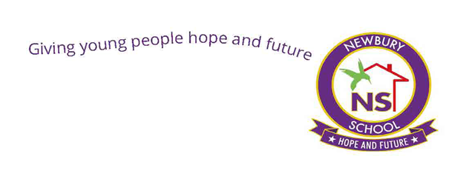

CURRICULUM
POLICY

NEWBURY SCHOOL
2023-2024

OVERVIEW

Curriculum Intent
The Newbury School curriculum is designed with the word access in mind and is dedicated to providing education that is broad, balanced, engaging and student centred. At Newbury we understand that many of our students may have missed significant chunks of their learning and have learning gaps, misconceptions and SEMH needs. Therefore, we aim towards supporting pupils in their personal and social development in order that they can access the learning opportunities provided and develop into lifelong learners.
The curriculum at Newbury Independent School (NIS) refers to all the planned activities organised for our pupils to promote learning and personal growth. This policy also highlights the importance of our “hidden curriculum” whereby our pupils learn from the experiences they have at Newbury, from the way they are supported with care, our expectations of them and cultural capital they experience through embedding British values. The is tied in with our core values of CARE (communication, application, respect and education). Which are also derived from the company values of transparency, honesty, integrity and consistency.
The essential aim of the policy is geared towards supporting pupils in their personal and social development in order that they can access the learning opportunities provided and develop into lifelong learners. This ensures our students are prepared for the world outside formal education. To that end English, Mathematics, Science and PSHE are at the core of the educational provision of Newbury. Every aspect of our school life promotes the Spiritual, Moral, Social and Cultural development of our pupils.

SCOPE

This Policy is an inclusive policy designed to provide effective learning opportunities for all pupils by setting suitable learning targets and responding to their diverse learning needs. It is a holistic policy, which aims to overcome potential barriers to learning. Its objective is to educate our pupils in the knowledge, skills and understanding they need in order to lead fulfilling lives. It recognises the spiritual, social, moral and cultural factors, which significantly affect pupils' ability to learn and to achieve.
The focus of our curriculum is to cultivate the social and emotional development of the young people in our care. Alongside the core lessons students have opportunities to expand the breadth and depth of their cultural experience through art, PE, IT skills, (embedded in lessons throughout the curriculum) and humanities.

OUR VISION

Newbury Independent School believes in fostering a love for learning in our students. Encouraging them to try new and exciting things, which in turn will give them a solid foundation to build on.
Our vision is to develop well rounded, confident and responsible individuals who aspire to achieve their full potential.
We will do this by providing a welcoming, happy, safe, and supportive learning environment in which achievements are celebrated. We believe that all children should enjoy their learning, achieve their maximum potential and become independent life-long learners.

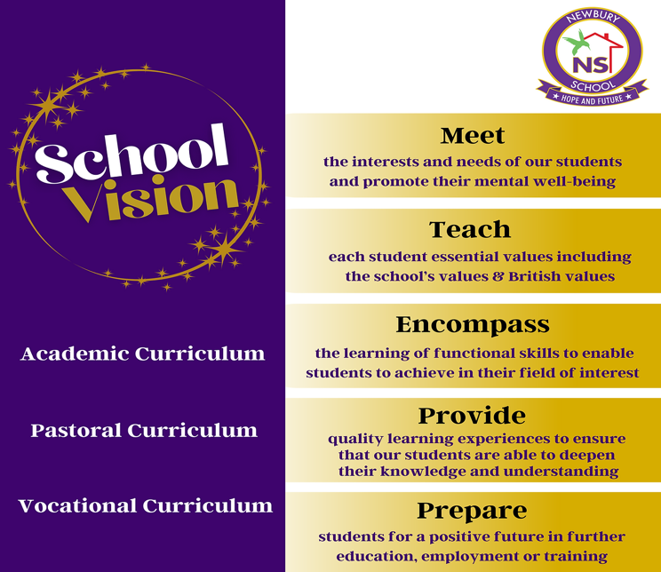

RATIONALE
At Newbury School, the aim of our broad and balanced bespoke curriculum is to give every student an equal opportunity to discover his or her strengths, develop their interests, and provide opportunities for personal development. This is geared towards facilitating students to be fully immersed in the ethos and life of the school. Many of our students have missed out months and even years of education, therefore it is imperative that the curriculum not only prepares the students for GSCEs or Functional Skills, but also fills the gaps in their knowledge.

It is also important for the curriculum to build the confidence of the students and raise their self-belief, to challenge previous narratives they may have been given about their ability to achieve. Keeping these goals in mind the curriculum is built with the themes surrounding the competencies-based model that guide our PSHE and SMSC program. This is so that the curriculum is easily accessible, and students develop skills that will prepare them for life outside of school.

The curriculum has a focus on improving students’ current knowledge, cultural capital and deepening learning in order to develop responsible citizens ready for their future. The themes that are embedded in the curriculum are independence and aspirations, autonomy and advocacy and choice and influence. These competencies seek to develop the whole student, academically, mentally and socially.

In addition, the curriculum will seek to enable students to develop the skills and mind-set of self-directed lifelong learners through the enrichment program it provides, skills such as critical and creative thinking, skilful communication and demonstrating care for self and others. By investing in their cultural capital and interests we seek to enrich and develop all our students.

This is a dynamic document, as we will be constantly striving to meet the diverse needs of our students through our evolving curriculum and ensure that our students achieve to their fullest potential. Our overarching aims are the foundation for our interdisciplinary curriculum.

MANDATORY PROCEDURE

Aims:

The aim of our curriculum is to provide the best learning opportunities and environment for our students so that they can be functional contributors to society this is achieved through the following aims:

- To enable all pupils to learn and develop skills to the best of their ability
- To engage pupils and promote a positive attitude towards learning
- To enable all pupils to have a positive experience of education.
- To provide a broad range of curricular opportunities that cater for the interests, aptitudes and particular needs of pupils and ensure progression in learning.
- To provide consistency across the curriculum in all subject policies.
- To establish appropriate, coherent links across the curriculum and across all Key Stages.
- To ensure the curriculum meets the aims of the School in order to maximise reintegration
into future educational opportunities and effective participation in adult life.
- To enable our pupils to have respect for themselves and develop a positive self-image of
themselves as successful learners and successful citizens.

IMPLEMENTATION AND REVIEW

It is important that our curriculum is constantly being reviewed we believe that our curriculum is dynamic and adaptable and caters to a wide array of needs presented by our students. The curriculum review team will consist of members of the SLT and representatives of the teaching staff to give holistic view of the curriculum, this is to quality assure that the curriculum meets the needs of our students. Evidence gathered from evaluation regarding the effectiveness of the policy together with any revised statutory curriculum guidance will determine the next review date. The curriculum planning team will meet at minimum once per half term to discuss the effectiveness of the curriculum and propose any changes needed to improve the provision within our school.
The aims will be achieved by:
- Careful planning the curriculum at three levels:
- Long term planning which relates to the National Curriculum (KS3 & KS4), ASDAN and Functional Skills provides an overview of topics or areas to be taught.

- Medium term planning which gives clear indications of objectives, success criteria, differentiation and assessment opportunities to support learning in each topic/ subject area.

- Short term planning which teachers prepare with learning objectives for each lesson and targets for individual pupils, specific activities, resources and deployment of teaching assistants defined to promote learning.

- Working in partnership with our parents, detailing expectations in our home school agreement and maintaining contact with parents so they can fulfil their role in their child’s learning.
- Offering a broad and balanced curriculum, which will inspire, challenge and safeguard our pupils whilst still encouraging our pupils to take managed risks.
- Providing a well-planned curriculum that will support our pupils in a smooth transition between phases and settings.
- Maximising pupil achievement in all subjects regardless of gender, race and ability by developing schemes of work which engage, motivate and challenge.
- Providing an Individual Education Plan for each pupil to facilitate curriculum access and meet specific requirements.
- Enabling each pupil to become a confident individual and to see themselves as a successful learner who can relate well to others and form good relations.
- Developing the relevant skills to become independent learners and effective members of society in order to reintegrate successfully into mainstream, special school or college placement.
- Developing an awareness in the pupil of how they learn and that these skills can be applied in all subject areas.
- Ensuring the curriculum is enhanced throughout by technology.
- Creating an ethos in which the quality of teaching and learning is continually evaluated and
improved.

- The curriculum is delivered through 1:1 or small group teaching, hence learning is personalized and enables teachers to build positive relationships with students. Enabling routines and boundaries to be established with limited peer pressures.

At NIS we recognise that we may need to organise learning in a different way and therefore we use various forms of assessment and evidence, taking part in project work that draws on several subject areas to extend access to learning and learning opportunities. This is mainly achieved through the ASDAN Life Skills challenges.
Effective use of resources to meet aims and support curriculum development in order to enable effective development and delivery of the curriculum:
- Termly school meetings are planned to quality assure the curriculum provision and
moderate staff’s assessment of learning.
- Teachers and support staff, with qualifications and experience to meet its needs, deliver the
curriculum.
- Resources that allow the curriculum to be effectively taught.

- Training is given high priority for teachers to develop and maintain current subject
knowledge.
- Alternative Provision School management undertake to use human, physical and financial
resources effectively and efficiently.

Curricular opportunities
The Alternative Provision School provides education for pupils with special educational needs and there has to be a flexible approach to curriculum delivery. The spiritual, moral social and cultural development is at the core of our work. Account is taken of gaps in pupils' learning resulting from missed or interrupted schooling and of the difficulties related to emotional or behavioural problems. Age-related programmes of study are not always appropriate. For individual pupils to make progress it is sometimes necessary to select work from an earlier or later key stage. The aim is for pupils to achieve as high a standard as possible. The curriculum is delivered through well-structured, efficiently planned lessons that take account of assessment and prior learning to ensure that the individual needs of pupils are met.
The curriculum provides opportunities for all pupils to participate actively in their learning through regular individual sessions where progress is reviewed and targets are set.
Teaching is delivered individually or in small groups. Group tuition is full time and provision is made for 25 hours.
Groups can be made up of pupils from different years and work is carefully planned to ensure that each one is working at an appropriate level. The approach to ICT is cross- curricular and e-learning is an important aspect of the curriculum.
Key Stage 3 and 4 pupils receive a core curriculum of English, Mathematics, PSHE, Science, IT and Physical Exercise. The curriculum is further enhanced by a variety of enrichment activities and programmes within the local community. A personalised pathway is developed for pupils which is facilitated through a varied menu of provision both on site and with local community providers. NIS works in partnership with examination centres and Key Stage 4 courses will lead to external accreditation where appropriate.

Importance of Literacy and Numeracy
At Newbury School literacy and numeracy are viewed as life skills. Literacy is promoted across the whole school and not isolated in English sessions only. It involves students to develop skills in reading, writing, listening and speaking competently and confidently. Numeracy is developed across the school and much like literacy is not isolated only in math lessons. Students are assed at the beginning of the term by GL assessments. This lays the foundation for setting a six-week numeracy and literacy target each half term.

Literacy and numeracy is promoted through personal development and tutorial program where students complete tasks and activities to improve and fill gaps in their literacy and numeracy.

SMSC thread interwoven in the curriculum
The curriculum is divided into three threads, behavioural, academic and vocational and interwoven throughout is the SMSC curriculum. This integration ensures that aspects of the SMSC curriculum are considered in all areas. There is emphasis in PSHE and personal development with the competencies model being delivered to students. This is an important aspect as we are aware of not just the emotional and academic gaps our students may have but the challenges and vulnerabilities they face in the wider community. The competencies model is taught through themes which are independence and aspirations, choices and influence, autonomy and advocacy. This will equip them with skills to be adaptable in the wider world. This ties in well with British values and cultural diversity and will further encourage students to develop a voice and be advocates for themselves.

Work Related Learning

A program is in place for students in Year 7 and upwards in which pupils learn about the world of work focusing on different careers. Students receive career advice and opportunities to visit work sites and open days for college. Careers education is important and learning the skills for work helps develop our students for employability. In year 11 students will have opportunities to complete work experience in order to supplement their experience to add to their CV’s.
Their experience is complemented by our partnership with Envirohort and changing education apprenticeships and careers. Through these programs students have the opportunities to complete work-based hands on vocational opportunities equipping them with the skills to access the world of work.

Behaviour for learning
Students' access to the curriculum is supported by an effective behaviour and pastoral programme. At Newbury many of our students have SMSC needs and they require the tools of support in order for them to thrive as individuals. Behaviour in the school is supported by strong pastoral support that has a focus of underlying care and nurture. Organising the students into small groups with keyworkers support creates a safe and positive environment for students. The students also know their allocated key worker just in case they need to have a drop in session to meet their needs. This walks hand in hand with the school’s Behaviour for Learning policy.

Students are risk assessed for compatibility on different sites, in order to keep anxiety low. This non-threatening environment helps students to be better able to access the curriculum. Students’ behaviour is also supported by a very strong school home liaison system. A strong relationship between home and school facilitates consistency, which lowers anxiety enabling better access to the curriculum. Behaviour is also managed through a very robust reward system, the school’s Points market place. Students have multiple opportunities during the day to which they can earn points both within lessons and outside in the school community. Teachers highlight positive behaviours and remind students that the wrong choice comes with negative consequences. The points are reviewed at the end of every day. Students know that every lesson is a new start for them. At the end of each week points are reviewed and the student of the week is selected. In tutorial targets are set to either improve poor behaviour or maintain good behaviour, highlighting the positive behaviours of the week.
During the week students are given certificates for their points, and or outstanding behaviours. At the end of each half term they have a choice of vouchers or a small monetary reward in keeping with the value of the points kept. Teachers are encouraged to motivate students by identifying good behaviour and offer them a positive phone call home. A Newbury School postcard is also sent to the students home in recognition of their good behaviour. Daily staff briefings enable staff to have two opportunities daily (morning briefing/evening briefing) to discuss students’ risks, discuss strategies to minimise risks, share good practice and discuss students' preferred learning styles.

Information from the briefings and from daily parental contacts are used to update the students risk assessments and one-page statements. The constant flow of information equips staff with a range of strategies, making them more proactive than reactive in their approach to behaviour management. Where the needs of students need a more in-depth understanding, the school uses the Antecedent Behaviour Consequence (ABC) approach to do a functional analysis, in order to inform all staff of the reasons behind the behaviour and plan strategies to help.

Assessment

At NIS it is the expectation that the assessment of pupil progress is planned within long- and medium-term plans.
Initial assessments are used to set the baseline for all students and conducted via GL assessments. This informs the basis for setting targets at the start of the academic year and term.
All staff are expected to implement the school’s Teaching, Learning, Assessment and Marking policies to ensure that pupils are fully aware of their targets. They should know how they can achieve their targets and are given sufficient guidance relating to their progress. Pupil evaluation of learning is built into our points system where learning and social behaviours are considered. There are two main ways through which are students are assessed to ensure progress is made. Using our data management system objectives (targets) are RAG rated based on in formative assessments and student feedback.
Summative assessments occur once a term consisting of no more than five questions to assess the content taught over that term. Each test is standardized and approved before administering.

From the assessment, question level analysis and post assessment strategy documents are completed to inform future targets and identify gaps in learning which then further informs future planning.
Our assessment process informs teaching expectations and enables them to be adjusted and reflected in Individual Education Plans. At all times we refer to achievements to inform planning for individual pupils.

Monitoring and Evaluation

Our curriculum and its implementation is monitored by the School Leadership Team to monitor aspects of curriculum provision in a systematic, planned way. Schemes of Work (Medium Term Plans) are given to the Deputy Head Teacher for scrutiny and discussion and lesson observations are integral to our performance management cycle. Staff report on lesson objectives and progress against individual targets on a termly basis through Pupil Progress Meetings and consider what needs to be maintained or develop to ensure progress.

The curriculum will also be monitored through:
- Staff attending INSET in relation to curriculum development
- Baseline and ongoing assessment through BKSB, target RAG rating which allows progress to be measured
- Individual Education Plan targets and success criteria for each pupil taught
- Examination results

Any issues arising through curriculum monitoring are fed back to SLT and solutions are found e.g. further training,

Consideration is also given to feedback from pupils and their parents / carers at the end of reviews. Review meetings are regularly scheduled with parents to enable us to formally report on progress and to make any amendments to our approach to allow the pupil to access learning should that be necessary.

Curriculum Impact

- Pupils develop a growth mindset and higher self-efficacy, as measured through SEMH assessments.
- engaged young people in their learning
- good levels of attendance to lessons and in education because the young peoples needs are met.
- The personalised approach from specialist staff means that pupils make accelerated progress in their SEMH.
- Pupils attain well in qualifications so that they are academically ready for the next stage of education or employment relevant to their aspirations and interests.
- The broad curriculum founded on preparing for adulthood means that pupils have the corequisite social, emotional, communication and independence skills to access these next steps successfully.
- Students achieve purposeful qualifications that lead to positive post 16 destinations.
- Student achieve a wide range of quality nationally recognised qualifications.
- Students that are able to use coping skills and resilience to manage own emotions and behaviour inside and outside of school.
- Students who are actively involved in the learning process and are able to reach aspirations and life goals.
- Students who have grown in confidence and independence in regards to work related and employability skills.
- Students reaching individual attainment targets/goals (ITAs) each half term/termly/annually
- Students who are able to recognise small steps of progress and are able to celebrate successes.
- Students’ self-esteem and self-belief is strong and they are able to move onto the next stage in life with confidence.

Complaints / Concerns

Parents/ carers who have concerns about any aspect of the curriculum for their child, should discuss these with the pupil’s teacher in the first instance. If the issue is not resolved, contact should be made with the Head teacher.

Please refer to the related NIS Policies:
- All individual curriculum policies
- Teaching and Learning
- Equal Opportunities
- Personal, Social and Health Education (PSHE) ICT
- Marking and Assessment Policy

This policy has been written & authorised by:

Name: | Shane Watson
Position: | deputy head teacher
Date: | September 2023
Next review date | july 2024
authorised by: | To be ratified

