BEHAVIOUR POLICY
NEWBURY SCHOOL

Contents

- Legislation and statutory requirements
- Definitions
- Introduction + Aim
- Trauma + Education
- Behaviour Approach
- Behaviour Management Cycles
- Parental Engagement
- Damages to School Property
- Pastoral Approach
- Damages to School Property
- Pastoral Approach
- Monitoring
- Pupil code of conduct
- Verbal De – escalation strategies
- Responsive Co Regulation Plan
- Training

Legislation and statutory requirements
This policy is based on advice from the Department for Education (DfE) on:
- Behaviour and discipline in schools
- Searching, screening and confiscation at school
- The Equality Act 2010
- Use of reasonable force in schools
- Supporting pupils with medical conditions at school
- KCSIE 2022
It is also based on the special educational needs and disability (SEND) code of practice.
In addition, this policy is based on:
Schedule 1 of the Education (Independent School Standards) Regulations 2014; paragraph 7 outlines a school’s duty to safeguard and promote the welfare of children, paragraph 9 requires the school to have a written behaviour policy and paragraph 10 requires the school to have an anti-bullying strategy requires the school to have a written behaviour policy and paragraph 10 requires the school to have an anti-bullying strategy.

Definitions
Misbehaviour | Disruptive in lessons  Disruptive in corridors between lessons  Disruptive during break and lunchtime  Non – completion of classroom work  Poor attitude towards others + learning  Defiance  Property damage
Serious Misbehaviour | Repeated breaches of the school rules  Any form of bullying  Any form of abuse  Vandalism  Theft  Fighting  Substance misuse  Discriminatory behaviour  Possession of any prohibited items  Disrespect towards staff and others  Unauthorised use of mobile phones or electronic equipment  Unauthorised use of fire prevention equipment
Critical incidents | A critical incident may be defined as any sudden and unexpected incident or sequence of events that cause trauma within the school environment and overwhelms the normal coping mechanisms of the school.

Introduction + Aims
Newbury Independent School strives to create a trauma - informed school community, creating an atmosphere that fosters healing, resilience, and positive growth for all students. This trauma informed approach is embodied by our aspiration to build a nurturing and caring ethos which permeates our school environment, promoting a sense of safety, trust and belonging. We have developed a Behaviour & Attitudes Policy which places relationships at the heart of our provision in order for our students to thrive, both academically and in relation to their wellbeing. This policy aims to develop a more consistent and relational approach towards behaviour management for children and young people with social, emotional and mental health (SEMH) needs. It recognises how through trauma informed approaches in educational settings, the outcome can support an increase in positive behaviour regulation skills.
Trauma & Education
Trauma is ‘the lasting emotional response that often results from living through a distressing event’. Experiencing a traumatic event can harm a person's sense of safety, sense of self, and ability to process emotions, regulate behaviour and navigate relationships. Children and young people may experience trauma through a number of different ways. Research into adverse childhood experiences (ACEs) consistently shows that a set of 10 adverse experiences in childhood are associated with an increased risk of mental health and behavioural problems alongside additional difficulties in later life (Early Intervention Foundation, February 2020). These adverse experiences being; physical abuse, sexual abuse, psychological abuse, physical neglect, psychological neglect, witnessing domestic violent, having a close family member who misused drugs or alcohol, having a close family member with mental health problems, having a close family member who serviced time in prison, parental separation or divorce on account of relationship breakdown.
It also must be noted that there are also several other experiences and factors that might contribute to poor outcomes, including economic disadvantage, bereavement and discrimination. Nevertheless, we cannot assume that if an individual experiences ACEs as a child, negative health outcomes are inevitable. The likelihood of ACEs impacting future health is different in every individual and depends on a variety of factors, most particularly, levels of resilience.
It is also important to acknowledge the physical, neurological and behavioural impact of trauma. When the human brain experiences a stressor, there is a decrease in blood flow to the pre-frontal cortex (PFC) - the part of the brain responsible for decision making, planning, impulse control, moral reasoning and sense of self. The developing brain remembers traumatic events and abusive experiences, so that a survival response can be triggered even in the absence of danger. This can appear as flight, fight or freeze behaviours and responses. Activating this state of heightened stress response is a survival strategy but for those who have experienced long-term or multiple trauma, it may become their way of being. By knowing more about the neuroscience behind the changes in the brain resulting from trauma, helps us to understand and interpret our students behaviours and demonstrate effective practice.
Children and young people who have experienced trauma are also much more likely than others to experience ‘toxic shame’. Toxic shame can be defined as an ‘overwhelming and relentless sense of unworthiness, inadequacy, and self-disgust’. Children and young people who experience toxic shame are likely to find any form of discipline challenging, and may: misinterpret well-intentioned or constructive feedback as being a personal attack against them, ruminate over/find it difficult to move on from discipline, find public discipline or praise difficult to tolerate (and demonstrate this through challenging behaviours), appear to ‘hold a grudge’ quickly, recreate the chaos they have experienced in their early life and need more time to calm down following an episode of distress, compared to children who do not experience toxic shame.
We recognise that every child has his or her own experiences and insights, informed from experiences at home, in the community and at school. When children and young people witness violence or experience abuse and neglect, they can enter the classroom believing that the world is an unpredictable and threatening place – triggering them to remain in a state of heightened alert most of the time. With this understanding, as a school we prioritise being a trauma informed educational setting - one where all of our staff members recognise and respond to our students in a way that meets their social, emotional and mental health needs. We ensure that all staff accept students with unconditional positive regard in order to strengthen trust and value. Unconditional positive regard shifts our questioning of undesirable behaviour from “what is wrong with this child” to instead asking ‘what has happened to this child?’ With this in mind, staff can remain mindful that the student is more than what is happening behaviourally.
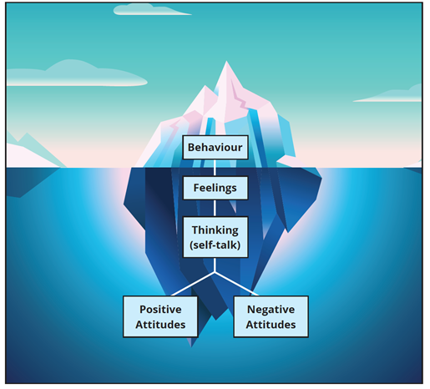
What we see
Withdrawal
Bullying
Physical Aggression
Outbursts
Absconding
Disruptive Behaviour
Verbal Aggression
Defiant Behaviour
Crying
Attention Seeking
Tantrums

ACE’s
Trauma
Home Life
Internal Working Model
Need to Connect
Need for safety
Need to escape

What we do not see but need to make space for
Behaviour Approach
We understand that the social and emotional development of our students may have been impacted due to adverse childhood experiences. Therefore, our Behaviour Approach reflects the needs of our students from a trauma informed perspective. Research on attachment and trauma strongly indicates that a relational framework is more effective in supporting children and young people’s behaviour. Therefore, we focus on Connection before Correction – encouraging our staff to think empathically, and not punitively, about misbehaving students, in order to cultivate better relationships and help reduce poor behaviour. See below our Behaviour Approach Poster.
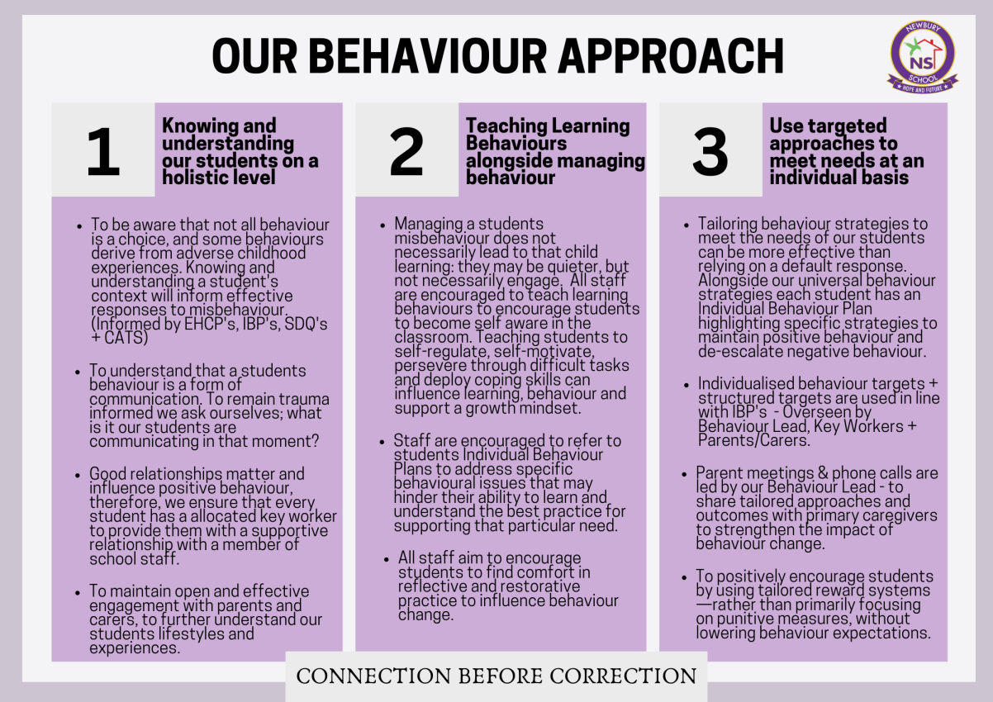

This approach provides an opportunity to;
- Prioritise relationships
- Empathise
- Promote resilience and self-regulation in the classroom
- Support students to feel safe in school
- Reflect on behaviour through restorative measures
- Encourage behaviour change.

Behaviour Management Cycles
At Newbury Independent School, we aim to primarily focus on positive reinforcement to encourage desired behaviour more frequently. Common forms of positive reinforcement include; public recognition, verbal and visual acknowledgments and praise. We incorporate such forms of positive reinforcement in our Positive Behaviour Cycle, please see below;
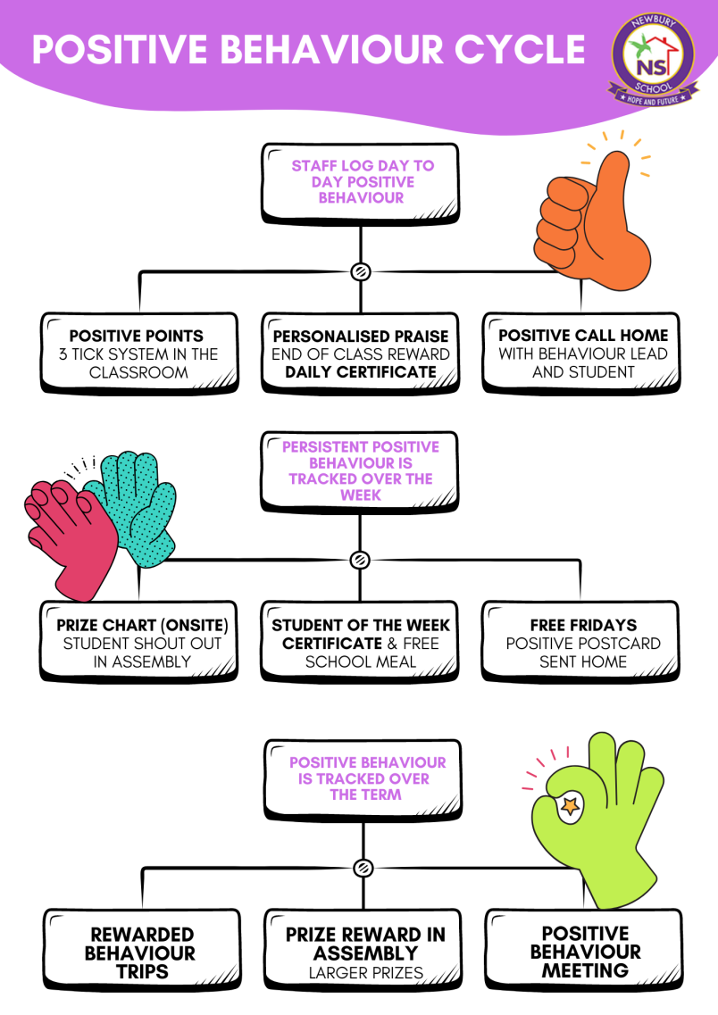
Box One – Encourages universal acknowledgement when students achieve the expected behaviour.
Box Two – Promotes individualized acknowledgement when students achieve the expected behaviour.
Box Three – Encourages parental engagement through the process to further recognize positive behaviour.

Box One – Encourages group rewards and group recognition.
Box Two – Promotes positive reinforcement and provides student choice with a free school meal.
Box Three – Promotes parental engagement and an end of week reward for students.

Box One – Encourages positive reinforcement and support students with their social development, interpersonal skills and self-confidence.
Box Two – Public recognition of positive behaviour
Box Three – Encourages parental engagement through to further recognize positive behaviour and strengthen family/school relationships.

Trauma informed approaches to behaviour aim to understand what a child or young person might be trying to say to us through their behaviour. Behaviour that challenges is not seen as a choice, but as being a communication of an unmet need. We encourage our staff to use a trauma informed approach to understand the function behind behaviour, before installing a consequence. We believe that our students benefit from having the opportunity to co-construct ideas for repairing a situation, alongside an adult. An emphasis should be placed on restoration, not punishment or blame, and should aim to reduce feelings of guilt in the child or young person. Below is our Negative Behaviour Cycle Poster, alongside annotations to gain clarity on the benefits of this practice.
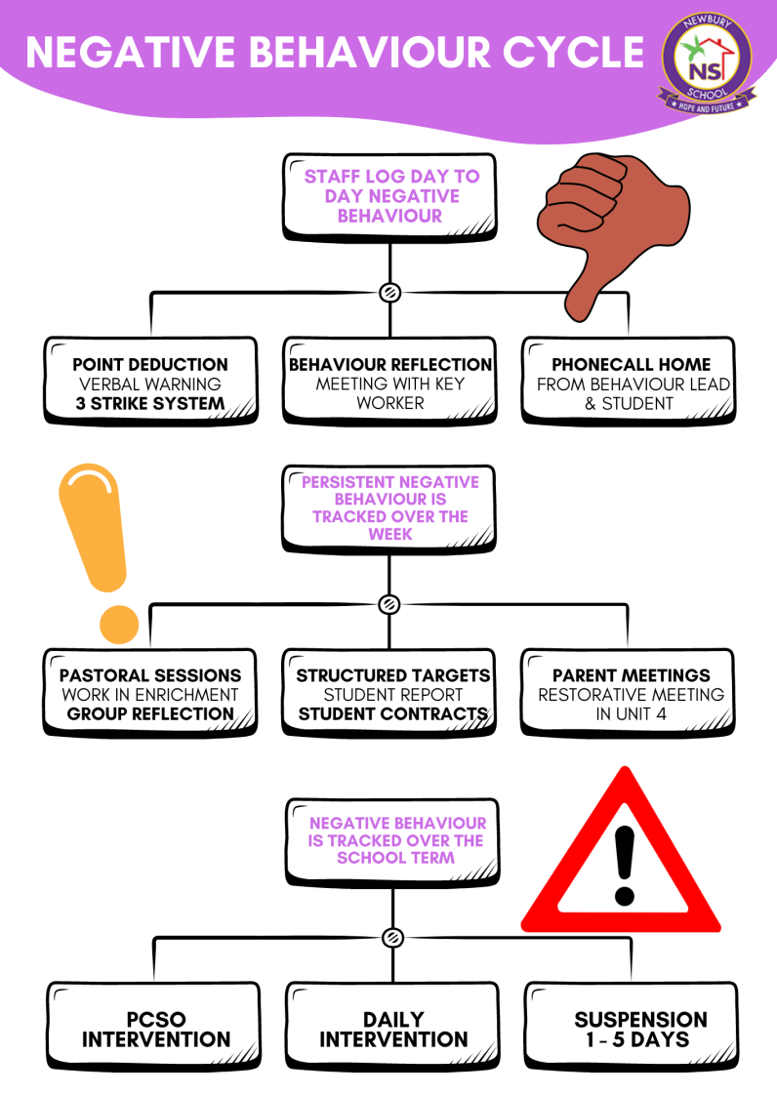

Box One – Enforces behaviour expectations and teaches students about consequence of misbehaviour.
Box Two – Promotes secure teacher – student relationships, trust + reflective practice at the earliest opportunity to ensure individual needs are met.
Box Three – Encourages parental engagement through the process to further strengthen behaviour management

Box One – Promotes Individual + Group Reflection and provides an opportunity for students to participate in a process that they are central to.
Box Two – Encourages accountability and self-achievement
Box Three – Supports parental engagement and restorative practice – encouraging student voice and behaviour change.

Box One – Encourages relationships with external agencies
Box Two – Promotes consistency and tailored support
Box Three – Encourages external behaviour reflection, whilst relationships are maintained through telephone contact, home visits & structured reintegration

Suspensions
At Newbury Independent School, we recognise the potentially detrimental impact of suspensions and therefore use this form of consequence as our final course of action. In order to avoid suspensions, we identify and meet the need being communicated through a behaviour at the earliest opportunity. We use restorative conversations alongside the students to reflect on triggers, thoughts and feelings and use a relational approach to behaviour management. However, we understand that on certain occasions, suspensions are required. On such occasions, the following strategies are used to help repair, restore and reintegrate;
  - Support the student to understand why they are suspended and ensure parents/carers are contacted immediately to further support behaviour management.
  - Send a Suspension Letter home to parents to provide further clarity on the situation and reasons for the suspension.
  - Provide the student with a Behaviour Reflection Worksheet to encourage independent reflection whilst at home.
  - Maintain contact with the student and their family throughout the process. This will include our Behaviour Lead telephoning the student at the beginning of each day, to check how they are doing and how the work they have been set is going. If the suspension is given for more than 3 days, a home visit will also take place.
  - Hold a restorative meeting for those involved in supporting the student to reduce blame and encourage reintegration, placing the students voice at the heart of the process.
  - Conduct a 1:1 Post – Suspension Meeting with the student and Behaviour Lead
Parental Engagement
Newbury Independent School values parent/carer engagement. We aim to ensure that all parents and carers are encouraged and supported to engage as partners in their children’s learning, and to become involved in the life of the school. We ensure that we maintain effective communication with parents/carers by prioritising the following actions;
  - Newsletter Updates for Parents/Carers
  - Website and Social Media Announcements
  - Morning and Afternoon Telephone Calls
  - Emails
  - Workshops/ Trips & Assembly Invitations
  - Home Visits
  - Pupil Progress Meetings/Parent Evenings
  - Behaviour Telephone calls (Positive + Negative)
  - Parent Surveys
  - Behaviour Strategy Meetings (Parent & School Collaboration Form)
  - EHCP Review Meetings

Damage to school property
At Newbury School, we aim to promote and maintain an environment that encourages our school values. We expect all students to respect and look after school property. However, for any damages to school property that have occurred by a student, a log will be kept to record the damages and a bill will be sent to the parents/carers to cover the cost of the damages, alongside an invite to a Behaviour Meeting.
Parents and carers will have 30 days from receiving the letter to make their payment and will be given the opportunity to speak to the head teacher who can offer advice and support.
Our costs to damages are fixed and stated in the table below. However, if school property is damaged and it is not stated on the list below, the price of this damage will be confirmed by the head teacher/ principal.

Costings for damages
School Property | Costing
Broken Pencil | 30p
Broken Ruler | 30p
Ripped Paper | 30p
Display board | £1
Writing on tables | £1
Writing on walls | £1
Broken ceiling tile | £1
Door handle | £10
Broken windows | £10
Broken radiator | £20
Fire Alarm | £20
Damage to wall | £20
Broken entry panel | £50
Broken door | £50
Broken fire extinguisher | £70

Pastoral Approach
We understand that the social and emotional development of our students may have been impacted due to adverse childhood experiences and individual needs. Therefore, our Pastoral Approach reflects the needs of our students from a trauma informed perspective and provides them with the emotional support required. We focus on our pastoral slogan ‘Regulate to Articulate’ – encouraging our students to be self – aware and gain the ability to self – regulate in order to articulate how they are feeling and what they need. See below our Pastoral Approach Poster.
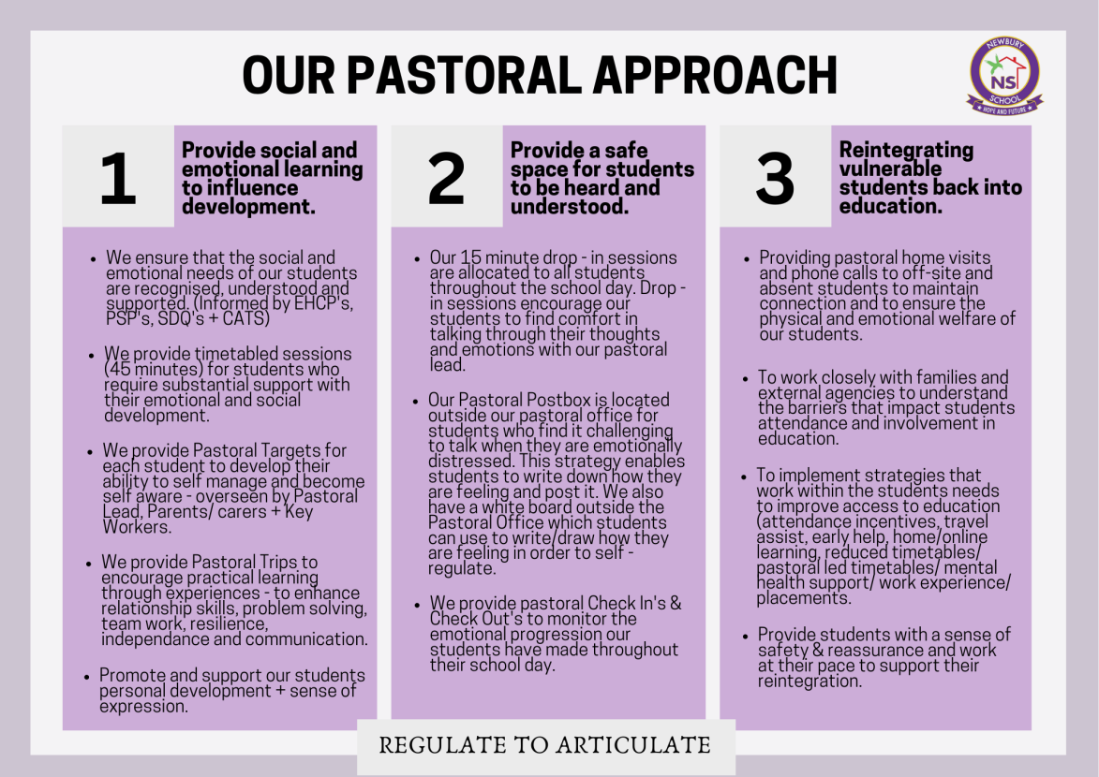

Monitoring
- The behaviour of students will be monitored daily and shared with all staff members in morning briefings and end of the day debriefing.
- A weekly review of behaviour across the week will be completed each Friday afternoon.
- Behaviour will be analysed termly and will be reflected in a behaviour report.
- All staff will be using our behaviour tracking system to monitor behaviour at a whole school approach.
- Based on data, students who are demonstrating concerning behaviour will be provided with tailored behaviour strategies to support them with their behaviour. They will also receive structured behaviour targets that will be stated in their individual behaviour plan and monitored by our behaviour lead and the student’s allocated key worker.
- To further monitor challenging behaviour students will also be placed on a behaviour report, which is monitored daily.
- Pastoral progress is monitored through pastoral support plans and pastoral targets.
- All pastoral sessions are tracked and monitored on our school tracking systems.

Pupil code of conduct
Pupils are expected to:
- Behave in an orderly and self-controlled way
- Attend school and all lessons on time
- Have the correct equipment required for their lessons
- Display a positive attitude towards learning
- Complete any refused work during catch up sessions
- Refrain from bringing drugs or items that may be used as a weapon to endanger others
- Refrain from attending school under the influence of drugs or other banned/ illegal substances.
- Adhere to the school's values (Honesty, Integrity, Consistency and Transparency)
- Show respect to members of staff and each other
- In class, make it possible for all pupils to learn
- Refrain from eating in lessons
- Move quietly around the school
- Treat the school buildings and school property with respect (Wilful damages will be chargeable)
- Wear appropriate clothing
- Phones are not permitted in lessons / Hand mobile phones in each day
- Accept sanctions when given

Verbal De – Escalation
We ensure that all staff practice verbal de-escalation strategies to manage the onset of challenging behaviour. Please see below;

De – escalation Technique | Explanation
Planned Ignoring | Staff will use intervals of ignoring to refrain from giving negative behaviour too much attention.
Fogging | Staff will refrain from responding in the expected way (which would be defensive or argumentative) in the hope of the student ceasing confrontation since the desired effect is not being achieved.
Reflecting Listening | Staff will pay respectful attention to the content and feeling expressed in the student’s conversation – allowing the student to feel heard and understood.
Suggestion | Staff will have an idea conveyed to the student, encouraging that idea to become the reality. Staff may propose a particular behaviour modification for the student to adopt.
Validation | Staff will recognise and affirm that a student’s feelings and opinions are valid and worthwhile.
Silence | By using silence, staff can prompt the student to reflect and provide a solution/answer.
Humour | Staff can use humour to defuse tension and dampen the negative effects of a situation.
Redirect | Staff can change the focus of a student’s attention from an undesirable behaviour to a more positive one. Staff can also redirect the student’s attention towards a topic of interest to create a new focus subject.
Changed environment | The environment can influence a student’s mood. Staff are encouraged to change the environment if they feel this may influence a student’s mood in a positive way.
Negotiation | Staff can use a negotiation technique that allows both parties to agree to an outcome which is mutually satisfying.
Interests | Staff are encouraged to know their students and their interests in order to build rapport and lighten a negative situation.
Action Plan | Staff are encouraged to make an Action Plan and complete this with the student before returning back to class. This helps the student refocus on a task understanding the outcome is to reintegrate back into the classroom.
Restorative | Staff are encouraged to resolve a conflict before sending a student back to class. This can be done by talking to everyone who is involved and encouraging all parties to explain their feelings and reasons for their behaviour.
Reassurance | Staff are encouraged to remove a student’s doubts or fears to encourage behaviour for learning.
Reminders | Staff can remind students of historic positive behaviour, times when they de –escalated well, times when they corrected their behaviour – to remind students that they are more than capable of doing it again.
Remain trauma informed | Having a complete understanding of how trauma exposure impacts emotions and behaviour can help support how we de-escalate expressive behaviour.
Ignore challenging questions | Staff are advised to refrain from engaging with students who ask questions that challenge their authority – as this is rarely productive, encourages a power shift and encourages the negativity to heighten.
Set boundaries | Staff are encouraged to define their limits and ensure they are respected.
Reduce the audience | Reducing the amount of students and staff that are around a distressed or aroused student can support with de –escalation.
Serene demeanour | Staff must remain calm with their body language and verbal communication.
Control | Staff must be mindful of control dynamics and remain in control of the situation.
Non – Judgemental | Staff are encouraged to remove all judgement and personal views from the situation and remember this is not about them.
Personal Space | Staff must be mindful of personal space to ensure the student is not triggered further.
Tag Out | If staff are experiencing difficulties with managing a student’s behaviour, they are encouraged to ‘Tag Out’ with another staff member – a change of face can also be refreshing for the student and help them regulate.
Resources | Staff are encouraged to have resources available that can support with the student self-regulating
Safe Spaces | Staff can utilise safe spaces for each student – providing a student with a calming space can support their regulation.
Words + Phrases | Staff are encouraged to read each students Individual Behaviour Plan to identify words and phrases that work best with each student.
Self – Regulate | Staff are encouraged to empower the student to self – regulate by understanding and managing their emotions and behaviour.
Stimulation | At times, students can display disruptive behaviour due to being bored. Staff are encouraged to stimulate students in an appropriate way in order to arouse interest, enthusiasm and excitement.

However, we recognise that occasionally a situation may escalate to a point where positive handling or restraint may need to be used to ensure the safety of a student or those surrounding. We will only exercise this option as a last resort. Please see our Positive Handling Policy for more information.

Responsive Co Regulation Plan

Responsive Co – Regulation Plan
Various types of responses supporting the emotional and physical safety of the student
State of regulation | Potential Displayed Behaviours | Responsive Co – Regulation
CALM  (Safe + Socially Engaged) | Steady Heart Beat  Steady Breathing Rate  Calm state of arousal  Open to social engagement  Expressive facial expressions  Expression tone of voice  Able to listen and process  Able to engage in learning | Maximise expressive social engagement  Fully engage using facial expression, voice and movement.  Encourage listening and expressive responses.  Engage thinking skills to reflect and make connection  Introduce gentle challenge through activity + learning  Apply positive reinforcement + points
MILD STRESS  (Alerted emotional state) | Slightly raised heart beat  Slightly raised breathing rate  Signs of mild agitation, frustration or/and anxiety.  Raised hyper-vigilance  Hyper-arousal  Lack of focus  Easily distracted  Increased movement  Early signs of needing to take control or helplessness | Connect through eye contact, facial expression & movement  Connect using the students name  Express calmness through body language and tone of voice  Attune to the mood, intensity and energy of the student.  Respond with awareness of the students agitation/ anger  Remain calm and gentle to sadness  Remain empathetic/ validating feelings  Use soothing and regulatory activities  Use verbal de-escalation strategies  Utilise a safe space + a trusted adult to diffuse cues escalating.
DYSREGULATED  (Immobilised + Mobilised) | Mobilised;  High levels of arousal/ distress  Hyper-vigilant  Difficulty listening and focusing  Mobilised; Fidgeting, jumping, climbing, running  Raised voices  Threatening behaviour  Oppositional behaviour  Immobilised;  Lowered heart rate  Lowered breathing rate  Reduced energy  Shuts off from surroundings  Muted/ Dissociates  Depressed state | Reduce social demands whilst remaining present  Provide individual attention  Verbal de – escalation strategies  Convey a calm and regulated state by presenting confidence and containment.  Use quiet, calm sounds and tones.  Reduce language + provide short clear directions.  Avoid asking too many questions  Use predicable routine  Reduce noise and audience  Remain aware of proximity  Minimum physical touch, use verbal communication for reassurance and support.
CRISIS  (The child or/and those around are unsafe) | Breakdown of coping behaviour  Inflated need to be in control  Distorted / confusion  Vulnerable  Self – harming  Harming others  No awareness to danger  Minimum verbal communication  Property damage  Physical/Sexual/Verbal Aggression | Crisis acion plan to be communicated with all staff + student to include their views if possible.  Physical intervention/ Positive handling  Isolation  Police involvement  Hospitalised  Outside agencies  Parental involvement

Training

Our staff are provided with training on positive behaviour management, which includes classroom management, and de-escalating strategies. In addition, staff will learn the proper use of restraint training and de-escalation strategies through LUPE. Positive behaviour management will also form part of continuing professional development.

This policy has been written and authorised by:
Name: | Shelika Evans
Position: | Pastoral & Behaviour Lead
Date: | July 2023
Next review date: | July 2024
Authorised by:

